**SMART STREET LIGHT SYSTEM**

**Introduction**

A smart streetlight is a public lighting fixture that incorporates technology, such as cameras, light-sensing photocells and other [sensors](https://whatis.techtarget.com/definition/sensor), to introduce real-time monitoring functionalities. Also referred to as adaptive lighting or intelligent street lighting, this type of lighting system is recognized as a significant step in the development of [smart cities](https://internetofthingsagenda.techtarget.com/definition/smart-city).The Smart street light provides a solution for energy saving which is achieved by sensing an approaching vehicle using **the IR sensors** and then switching ON a block of street lights ahead of the vehicle. As the vehicle passes by, the trailing lights switch OFF automatically.

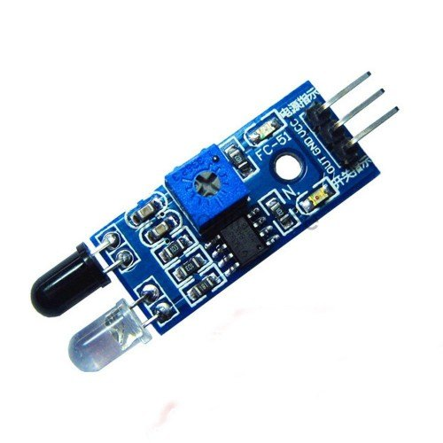

**Components**

* Cardboard, wood etc for road.
* Arduino
* Breadboard
* 3x IR sensor (with digital output)
* 4x High light LED
* connecting wires
* straws (to elevate LED's)

**Application**

**IR imaging devices**, optical power meters, sorting devices, missile guidance, remote sensing, flame monitors, moisture analyzers, night vision devices, infrared astronomy, rail safety

**Objective**

During this activity ,you will help students to achieve fiollowing objectives

1. Understanding the principle and operation of IR sensor

2. Design algorithm and flowchart to detect Vechile and street light get on

3. Programming IR sensor using Arduino uno

4. Interfacing IR sensor with Arduino uno

**Algorithm**

1. Define first sensor as IR1,second sensor as IR2,third sensor as IR3

2. define digital pins as outpin pin for LED

3. Initialse ports for IR sensor and LED

4.assign variable t1 to read value of IR1

5.assign variable t2 to read value of IR2

6.assign variable t3 to read value of IR3

7.Read values of variables

8.check values if vehicle is passing through IR1,then t1 gets HIGH and LED1 gets on

9.if vehicle is passing through IR2,then t2 gets HIGH and LED2 gets on

10.if vehicle is passing through IR2,then t3 gets HIGH and LED3 gets on

**Flowchart**

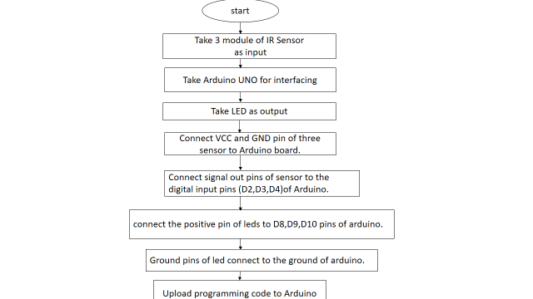

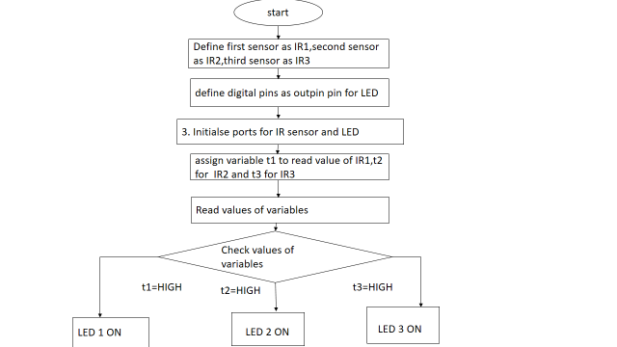

**Programming**

int IR1=2;

int IR2=3;

int IR3=4;

int l1=8;

int l2=9;

int l3=10;

void setup()

{

  pinMode(l1,OUTPUT);

  pinMode(l2,OUTPUT);

  pinMode(l3,OUTPUT);

  pinMode(IR1,INPUT);

  pinMode(IR2,INPUT);

  pinMode(IR3,INPUT);

}

void loop()

{

  int t1 = digitalRead(IR1);

  int t2 = digitalRead(IR2);

  int t3 = digitalRead(IR3);

  if (t1!=1)

   {

     digitalWrite(l1, HIGH);

     digitalWrite(l2, HIGH);

     digitalWrite(l3, LOW);

     while(t2!=1)

     {

     digitalWrite(l1, HIGH);

     digitalWrite(l2, HIGH);

     t2 = digitalRead(IR2);

   }

     digitalWrite(l1, LOW);

     digitalWrite(l2, LOW);

     delay(10);

   }

  if (t2==1)

   {

     digitalWrite(l1, LOW);

     digitalWrite(l2, HIGH);

     digitalWrite(l3, HIGH);

     while (t3!=1)

      {

        digitalWrite(l2, HIGH);

        digitalWrite(l3, HIGH);

        t3 = digitalRead(IR3);

      }

     digitalWrite(l2, LOW);

     digitalWrite(l3, LOW);

     delay(10);

   }

  if (t3==1)

   {

     digitalWrite(l1, LOW);

     digitalWrite(l2, LOW);

     digitalWrite(l3, HIGH);

     delay(2000);

   }

   else

   {

     digitalWrite(l1, LOW);

     digitalWrite(l2, LOW);

     digitalWrite(l3, LOW);

   }

    delay (1);

}

Hardware

1.Connect all the components as given in the circuit diagram.

ir sensor 1 ---> 2

ir sensor 2 ---> 3

ir sensor 3 ---> 4

2. connect all ir sensor's to +5v and ground with arduino board

3.connect the positive pin of leds are connected to these pins of arduino.

led 1 ------> 8

led 2 ------> 9

led 3 ------> 10

4. Ground pins of led connect to the ground of arduino.

